

**First Increment Prototype**

**Vacanza – AI Powered Travel Application**

**Team 2**

**Ahmet Serhat Şahin, 22101813**

**Damla Alçay, 22002369**

**Göksu Uzun, 22102745**

**Ömer Faruk Asil, 22002781**

**Ufuk Zencirci, 22102476**

Bilkent University

Department of Information Systems and Technologies

30.12.2025

Change History

|  |  |  |  |  |
| --- | --- | --- | --- | --- |
| **File Name** | **Document Type** | **Deliverable** | **Version** | **Submission Date** |
| Team2_Prototype_V1 | Microsoft Word 2024 Document (.docx) | 2B | 1 | 09.11.2025 |
| Team2_Prototype_V2 | Microsoft Word 2024 Document (.docx) | 2B | 2 | 30.12.2025 |

Change List

* Activity diagrams were confusing; it has been re-drawn.
* Class diagrams’ arrow directions were wrong, changed.
* Sequence diagram’s and class diagram’s methods aligned.
* DB diagram were design level, made analysis level.

# Use Cases and Functionalities Selected for First Increment Prototype

After a meeting with our project advisor, we decided to implement the use cases that are marked below.

Figure Selected Use Cases for Vacanza (for both Web and Mobile)

# First Increment Prototype

The first increment prototype demonstrates the interactive map exploration and filtering module of Vacanza, implementing the core features from Use Case 1.2 (Map Interaction and Filtering), Use Case 1.3 (Area Selection and POI Integration), and a partial implementation of Use Case 1.8 (Hotel Listing and Booking). Each numbered step below corresponds to the visuals presented in the prototype screenshots.

## Step I – Interactive Map and Default POI Display

* + 1. When the user opens the Home / Map + AI screen, a Mapbox-style interactive map appears as the main interface.
    2. The right-side control panel includes Draw (pen), Filter (layers), Map Mode (2D / 3D / Satellite), and Locate buttons.
    3. Colored POI pins represent Hotels, Restaurants, Parks, Monuments, and Events.
    4. Figures 1–3 illustrate the same POIs across different map modes: Figure 1 – 2D map view (default); Figure 2 – 3D perspective view; Figure 3 – Satellite view with realistic map textures.

## Step II – Applying Filters

* + 1. By tapping the Filter (layers) icon, the user opens the Filter POIs panel (Figure 4).
    2. The panel lists categories — Hotels, Restaurants, Events, Monuments, and Parks — each with its own color and icon.
    3. Toggling a category immediately updates the visible POI pins on the map.
    4. The user can combine multiple filters (for example, showing only Hotels and Restaurants) for customized exploration.
    5. This interaction demonstrates the Map Interaction and Filtering process (Use Case 1.2).

Figure 2D Map View Figure 3D Map View Figure Satellite Map View

## Step III – Activating Drawing Mode

* + 1. By tapping the pen icon, the user enters drawing mode (Figure 5).
    2. The icon glows blue to confirm activation.
    3. The user drags a finger on the map to sketch a freehand area.
    4. The drawn region appears with a soft translucent blue-green fill, defining a geographic zone for focused POI retrieval.
    5. This corresponds to Area Selection (Use Case 1.3).

## Step IV – Filter Panel After Drawing

* + 1. When the drawing is finished, the Filter POIs panel automatically reappears (Figure 6).
    2. Filters now apply only to the selected region, dynamically showing or hiding POI pins inside the area.
    3. This extends the filtering process from Use Case 1.2 into the user-defined area in Use Case 1.3.

Figure Map Filter Layers for Vacanza Figure 6 Drawing Mode on the Map Figure 7 Filter Panel After Drawing

## Step V - Results in Your Area (Hotels, Restaurants, Monuments)

* + 1. After filters are applied, the Results in Your Area panel slides up from the bottom of the screen.
    2. The panel features horizontal category tabs (Hotels, Restaurants, Events, Monuments, Parks).
    3. Figure 7 – Hotels tab showing relevant POIs within the area.
    4. Figure 8 – Restaurants tab listing dining options with Add to Route.
    5. Figure 9 – Monuments tab listing cultural and historical locations.
    6. This step continues the Area Selection and POI Integration workflow (Use Case 1.3).

## Step VI - Functional Coverage Summary

* + 1. This step continues the Area Selection and POI Integration workflow (Use Case 1.3).
    2. This prototype increment demonstrates:
    3. Use Case 1.2: Map Interaction and Filtering – controlling POI visibility and map modes.
    4. Use Case 1.3: Area Selection and POI Integration – drawing user-defined areas and retrieving contextual POIs.
    5. The AI Chat drawer is intentionally hidden in this version and will be implemented in the next increment.

Figure 8 Hotels List Figure 9 Monuments List Figure 10 Restaurants List

# System Model

## Activity Diagrams

Figure 11 Activity Diagram for UC1.2

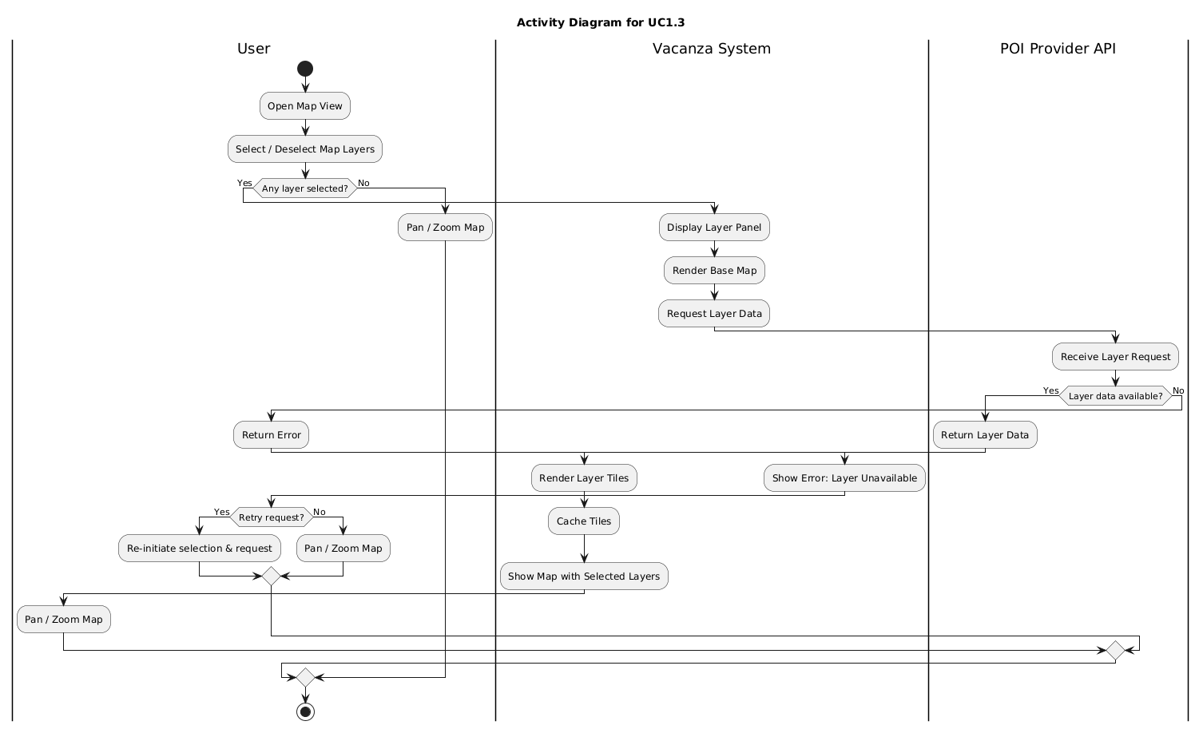

Figure 12 Activity Diagram for UC1.3

## Analysis Level System Sequence Diagrams

Figure 13 Analysis Level System Sequence Diagram for UC1.2

Figure 14 Analysis Level System Sequence Diagram for UC1.3

## Analysis Level Class Diagram

Figure 15 Analysis Level Class Diagram for UC1.2

Figure 16 Analysis Level Class Diagram for UC1.3

## 3.4. Database Design

Figure 17 Relational Database Design